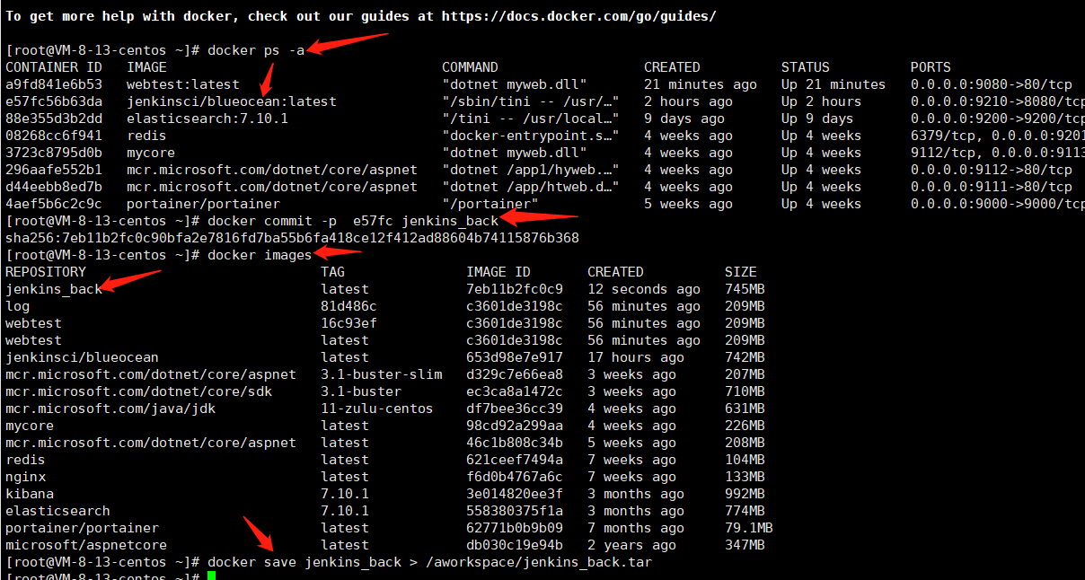

docker commit -p 58779d3f5a3f sqlserver-backup

docker save jenkins_back > /aworkspace/jenkins_back.tar

导入：

docker load < /aworkspace/jenkins_back.tar

恢复docker run -p 9220:8080 -p 9221:50000 --name myjenkins_back -d jenkins_back

相关文章

<https://blog.csdn.net/qq_20042935/article/details/106495071>